Science Research Projects Competition 2020
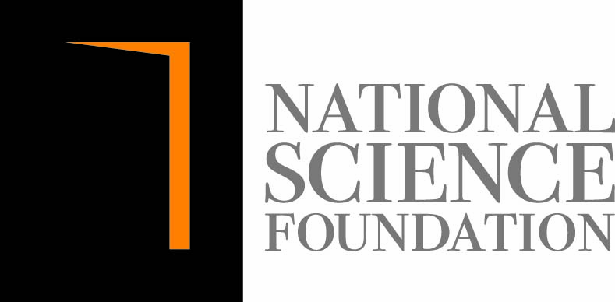
Organized by the National Science Foundation (NSF)
2nd Call of proposals

Format for preparation of the Project Proposal

- Title of the project:
Should be a brief one but sufficiently indicative the nature of the project.

2. Introduction:
Discuss the research problem that you have selected for your project.

3 Hypothesis:
Write the hypothesis that you have built in brief.

4 Objectives:
Provide the objectives of the research project, in point form.

5 Methodology:
Describe the methodology you applied for your research project.

6 Research Plan:
- Time frame – (About 06 months)
- Any other facilities, equipment and other resources required.

7. Details of the supervisor if there is a supervisor identified by you (refer to section 15 of SRPC guidelines)
Name (Prof./Dr/Mr/ Ms.)
Designation
University/ Institute
Mobile number
Email
Note: Please attach brief CV of your proposed supervisor

8. Details of the school
Name of the school
Address
Contact information | Phone  Fax  E-mail

9. Details of student

Name of the student
Grade
Gender
Age as at 01 May 2021
Name and contact number of parent

10. Details of parent
Name
Contact number
Email
Signature
Name and contact number of parent

11. Teacher in-charge of the project
Name
Contact Number
E-mail
Signature

I hereby certify that the project proposal submitted herewith for SRPC 2020 is a piece of work done by the above student.

……………………………...…………… …………………………………
Signature of Class Teacher Date

……………………………...…………… …………………………………
Signature of the Principal and official stamp Date

Note: Please e-mail the project proposal prepared based on the given guidelines to maduka@nsf.gov.lk or abhimani@nsf.gov.lk on or before 15th Aug 2020. The proposal should be prepared according to the format given. Indicate the subject of the email as “SRPC 2020- 2nd Call”. Once the schools started the original application need to be sent through the teacher in-charge of the project and the Principal.

Contact: Ms. Maduka Senaratne (maduka@nsf.gov.lk) or Ms. Abhimani Ranatunge (abhimani@nsf.gov.lk ), Scientific Officers, Science Popularization Division, National Science Foundation (Tele: 011-2696771 Ext 183 and 184)

Dr P.R.M.P. Dilrukshi Ranathunge,
Head, Science Popularization Division (SPD),
National Science Foundation, 47/5, Maitland Place,
Colombo 7.
Tele: 011 2209509 / 011-2696771 Ext 180
e-mail : dilrukshi@nsf.gov.lk

